Final Project Proposal
Name: Honghao Wang

1 Overview
As one of the key tasks in the field of Natural Language Processing (NLP), sentiment analysis has been widely applied in practical scenarios such as dynamic monitoring of social media public opinion, qualitative analysis of customer feedback on e-commerce platforms, and early warning of user sentiment risks in the financial sector. Its analysis results can directly provide data-driven support for enterprise strategic decision-making and product iteration optimization.
Among the widely used GLUE (General Language Understanding Evaluation) benchmark test sets in the current NLP field, only the SST-2 (Stanford Sentiment Treebank-2) task is designed for sentence-level sentiment analysis. However, this task is limited to the scope of positive-negative binary classification and fails to cover the multi-class sentiment classification needs with higher practical value in industrial scenarios. Based on this, this project selects the publicly available dair-ai/emotion annotated dataset on the Hugging Face platform — this dataset covers annotated texts of 6 emotion categories (joy, sadness, anger, fear, surprise, love) and serves as a classic benchmark data for multi-class sentiment analysis tasks. Nevertheless, it has the problem of unbalanced distribution of sample quantities across some emotion categories; meanwhile, there is still room for refinement in research on "validation of the effectiveness of specific data augmentation technologies" and "performance comparison of different technical paths (traditional machine learning vs. pre-trained large models)", and "comparison of performance across pre-trained large models with different parameter scales" for this dataset, which possesses clear practical and research value.
The core exploration directions of this project include three aspects:
(1) Investigating the impact of back-translation-based data augmentation technology on the model training effect of multi-class sentiment tasks;
(2) Verifying the performance difference between the pre-trained large model fine-tuning scheme and the traditional machine learning method in this task;
(3) Analyzing the performance improvement range of pre-trained large models with different parameter scales on the task.

2 Prior Work
In the field of text sentiment classification, data sparsity and class imbalance have long posed challenges to model performance improvement. Text augmentation technology, by generating samples with consistent semantics and diverse forms, has become a key technical approach to address these two issues. In the direction of basic text operation augmentation, the EDA method proposed by Wei and Zou integrates four core operations including synonym replacement and random insertion, offering a straightforward and efficient data augmentation approach for small-sample text classification tasks [1]. In another study, Guo and Mao transferred the Mixup data augmentation method to sentence classification scenarios, further expanding the application scope of basic operation-based augmentation techniques by linearly interpolating input features of random samples and synchronously modeling label distributions [2]. In the translation-driven text augmentation direction, Body and Tao adopted a multilingual back-translation strategy, leveraging expression differences between different languages to enrich the diversity of text samples [3]. Research by Kumar experimentally verified that Transformer-based translation models demonstrate notable strengths in preserving sentiment semantics [4]. Meanwhile, the direction of generative text augmentation has also achieved several practically valuable advancements—Whitfield utilized the GPT-2 model to directly generate new samples with consistent sentiment tendencies, effectively enhancing the diversity and coverage of datasets [5].
Once the class imbalance issue is addressed, two primary approaches dominate text sentiment classification: the traditional "representation-then-classification" framework and end-to-end classification leveraging large language models. When it comes to text representation, Salton and Jones introduced the TF-IDF algorithm to quantify word importance in text while effectively suppressing the interference of stopwords [6]; Mikolov proposed the Word2Vec model, which maps words into low-dimensional dense vector spaces to enable automatic clustering of semantically similar terms [7]. For classifier deployment, Pang adopted SVM as a classic model for traditional sentiment classification, and its suitability for high-dimensional text feature settings has been widely confirmed [8]; P Dhanalakshmi combined logistic regression with the VADER sentiment analysis tool, demonstrating that this integration delivers superior performance in sentiment analysis of airline tweets [9]; Samih employed the IWVS method and enhanced the F1-score of sentiment classification via the XGboost algorithm [10]. For text classification with large language models, Devlin adapted the BERT model to text classification tasks through fine-tuning, laying out a practical framework for applying pre-trained models to this domain [11]; Liu proposed an optimized BERT pretraining strategy (RoBERTa), which further boosts the stability and accuracy of text classification by adjusting the scale of pre-training data and refining training details [12].
After comprehensive research, this study plans to adopt four types of methods for the experiment: the multilingual back-translation method generates augmented samples with consistent semantics and diverse expressions through a bidirectional translation process of "source language-target language-source language", thereby alleviating the class imbalance problem of the dataset; the TF-IDF text representation method quantifies the importance of words in texts by calculating the product of Term Frequency (TF) and Inverse Document Frequency (IDF), converting unstructured text into high-dimensional structured feature vectors applicable for model training; the SVM classification method achieves accurate division of different sentiment categories by virtue of its ability to find the optimal separating hyperplane in high-dimensional feature spaces; meanwhile, two pre-trained models, bert-base-uncased and bert-large-uncased, will be fine-tuned—freezing the bottom feature extraction layers of the models to retain the general language knowledge acquired during the pre-training phase, and only fine-tuning the top-layer classification-related parameters to adapt to the target sentiment classification task. The former ensures training efficiency with a lightweight architecture, while the latter captures more refined semantic features with a larger parameter scale, thus completing end-to-end sentiment classification. More specific algorithm implementation details and parameter settings will be elaborated in the Method section of the final report.

3 Preliminary Results
The original dair-ai/emotion dataset exhibits a distinct class imbalance feature: sadness (4,666 samples) and joy (5,362 samples) account for a relatively prominent proportion, while love (1,304 samples) and surprise (572 samples) are relatively scarce in sample size (Figure 1). The boxplot of text length across different emotion categories indicates that all texts range from 3 to 70 words in length. Through analytical verification, there is no significant correlation between text length and emotion classification, suggesting that text length does not introduce systematic bias to the sentiment recognition task.

Figure 1 Data Distribution of the dair-ai/emotion Dataset
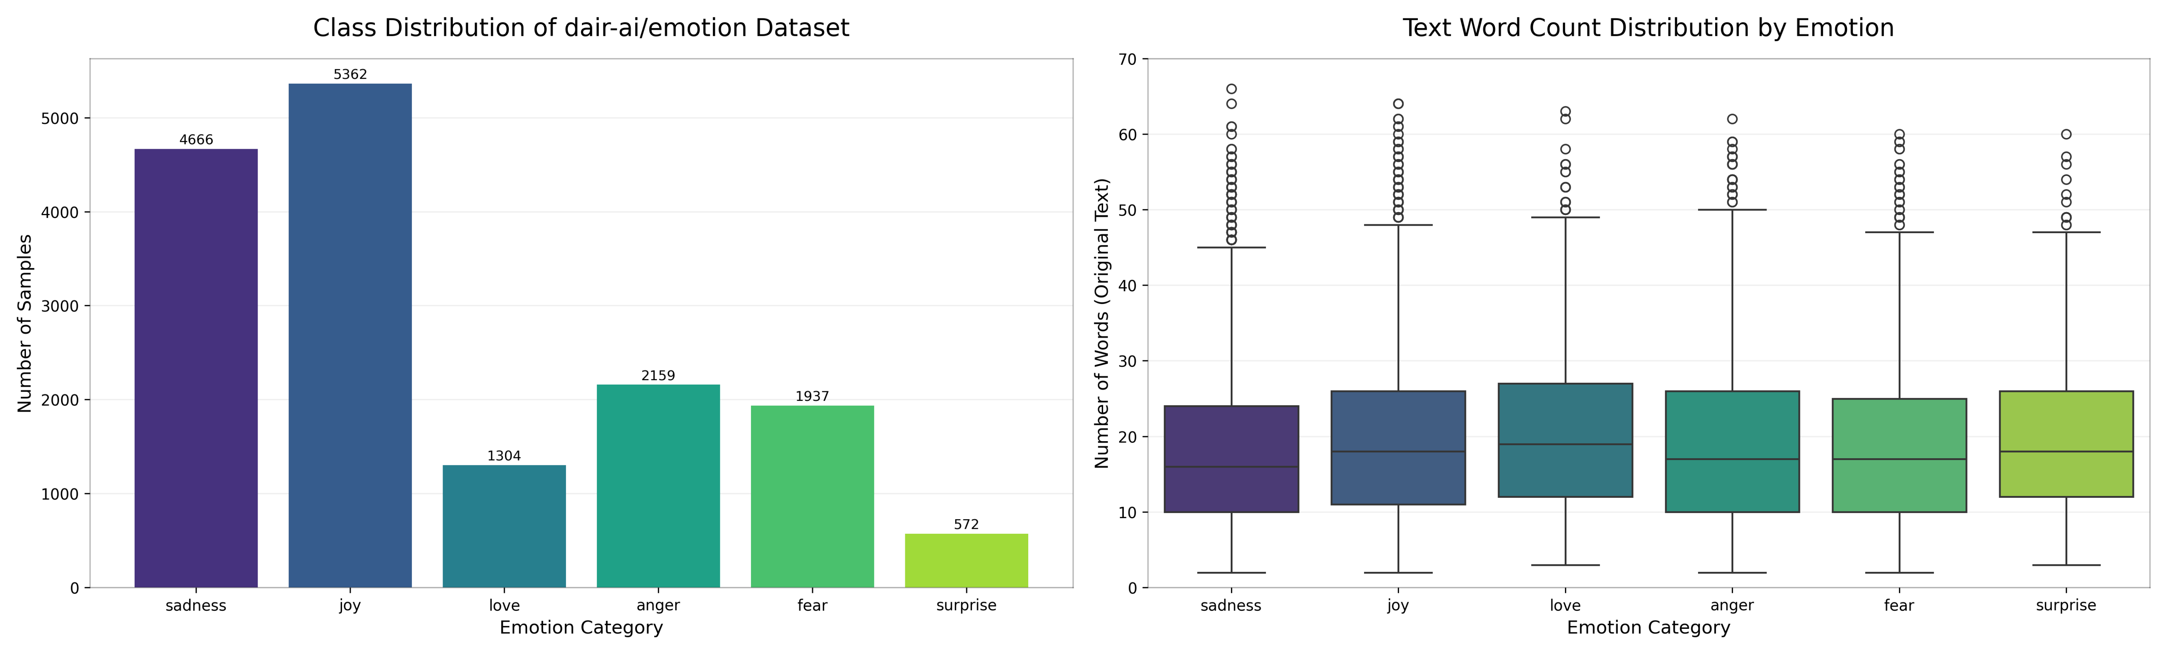

To alleviate the class imbalance issue, we employ a back-translation-based data augmentation approach. Specifically, for each emotion category, we randomly sample one sample from all samples of that category and then randomly select one pair from 8 English-foreign language pairs (English-German, English-Spanish, English-French, English-Chinese, English-Russian, English-Arabic, English-Italian, and English-Dutch) to perform back-translation, thereby generating a new sample of the same category. The translation models uniformly adopt the Helsinki-NLP series (specifically the opus-mt sub-series) from the Hugging Face Hub. This process is repeated until the number of samples in each category, after deduplication, is no less than 80% of the sample count in the largest category. Figure 2 illustrates the distribution of the augmented data, indicating that this method successfully expands the sample size while preserving the original text word count distribution without distortion.

Figure 2 Data Distribution of the augmented Dataset
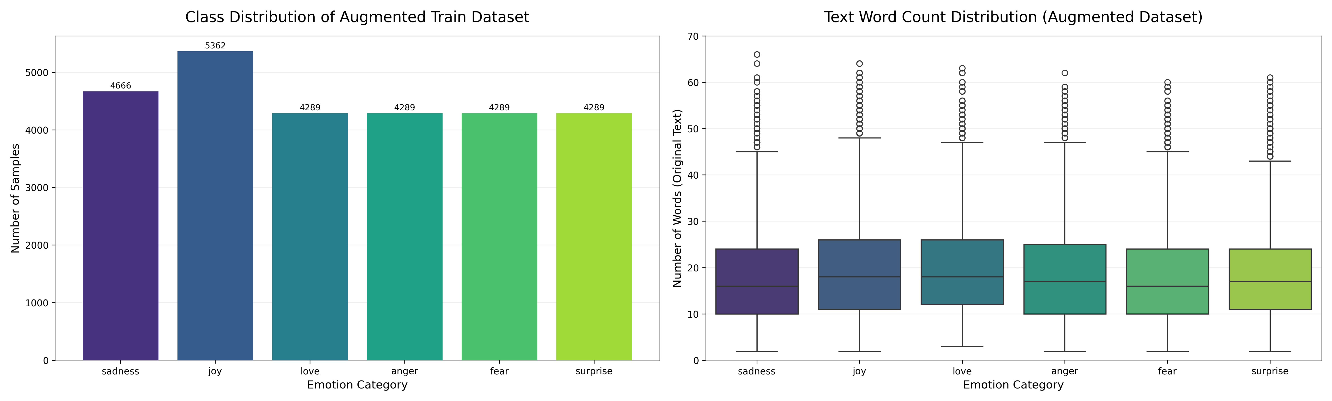

To evaluate the impact of data augmentation on task performance, we construct a baseline model using the TF-IDF+SVM approach for verification. Specifically, we first represent texts via the TF-IDF feature extraction method, setting the maximum number of features to 5000 to balance feature dimensionality and information retention; subsequently, we train a support vector machine model based on these features to complete the multi-class sentiment recognition task. The experimental results are shown in Table 1 and Figure 3: although the overall accuracy and weighted F1 score of the model decrease to a certain extent after data augmentation, the recognition performance on minority categories is significantly improved—among them, the prediction success rate of the surprise category increases from 0.58 (trained on original data) to 0.77. This greatly enhances the model’s ability to recognize scarce categories, thereby improving its practicality and engineering application value in real-world scenarios.

Table 1 Comparison of the TF-IDF+SVM on Original and Augmented Data
dataset | accuracy | weighted F1 score
original_data | 0.8935 | 0.8921
augmented_data | 0.8670 | 0.8703

Figure 3 Confusion Matrices of the TF-IDF+SVM on Original Data and Augmented Data
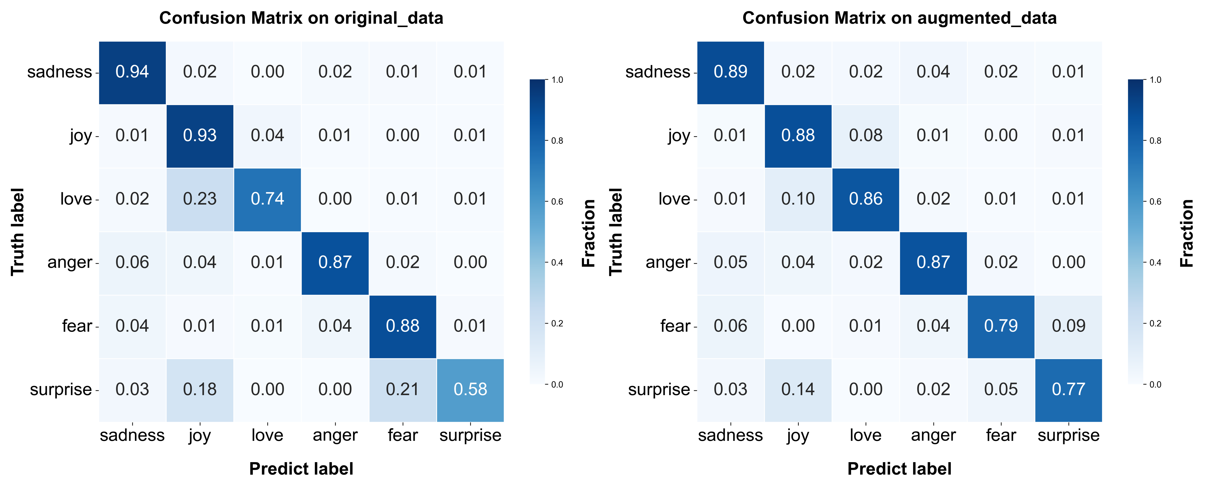

To verify the performance of pre-trained models in multi-class sentiment recognition tasks, we conduct fine-tuning on the bert_base_uncased model. The training parameters are set as follows: the maximum sequence length is set to 128, the batch size is set to 16, the learning rate is set to 2e-5, and the number of training epochs is fixed at 4. A performance comparison between this fine-tuned model and the TF-IDF+SVM traditional model shows that the bert_base_uncased model achieve significantly better overall performance than the traditional model—in terms of overall accuracy, weighted F1 score, and recognition rate of most emotion categories, there are significant improvements. Only in the recognition of the fear category, its accuracy rate is 0.72, slightly lower than the 0.74 of the TF-IDF+SVM method.

Table 2 Performance Comparison of TF-IDF+SVM and Bert_base_ft_emotion
method | accuracy | weighted F1 score
TF-IDF + SVM | 0.8935 | 0.8921
Bert_base_ft_emotion | 0.9300 | 0.9288
 | 0.9300 | 0.9295

Figure 4 Confusion Matrix Comparison between TF-IDF+SVM and Bert_base_ft_emotion
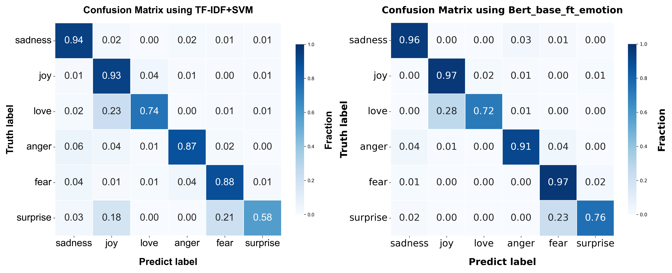

In this study, I use Python, learned from the course, as the core programming language for data processing, model training, and experimental analysis, covering the entire process from data loading to result visualization. I rely on the scikit-learn library to implement TF-IDF feature extraction and SVM model training, and use Matplotlib and Seaborn libraries to visualize experimental results such as class distribution, text length boxplots, and confusion matrices.
In addition, I adopt tools outside the course to meet specific task requirements: Hugging Face Datasets is used to load the dair-ai/emotion dataset, Hugging Face Transformers is used to load and fine-tune BERT pre-trained models, and open-source models from the Helsinki-NLP/opus-mt series on Hugging Face Hub are called to construct translation chains for back-translation-based data augmentation.

4 Project Deliverables
The core outputs of this project center on three categories of key achievements: first, a code repository with standardized annotations and reproducibility, encompassing three core functional modules—data augmentation, model training, and data prediction and analysis; second, a systematic and detailed experimental analysis report; third, clear clarification of the three core research questions through visualization—specifically, the mechanism by which back-translation-based data augmentation technology influences model training performance in multi-class sentiment tasks, the performance disparities between the pre-trained large model fine-tuning scheme and the traditional machine learning method (TF-IDF+SVM), and the performance improvement effect of pre-trained large models with different parameter scales on the task.
The corresponding sub-goals will be conducted in sequence following a practical workflow:
• Conduct visualization analysis of raw data.
• Implement back-translation-based data augmentation and evaluate its effect using the TF-IDF+SVM model
• Fine-tune the bert_base_uncased model and compare results with the TF-IDF+SVM model.
• Fine-tune the bert_large_uncased pre-trained model and compare results with the fine-tuned bert_base_uncased model.
• Develop an program supporting batch prediction and real-time prediction.

- Timeline
• Week 1-2: Acquire the dair-ai/emotion dataset from the Hugging Face platform, conduct its preliminary cleaning and the visualization analysis of sample category distribution and text length; simultaneously realize the development of back-translation-based data augmentation code using 8 language pairs (with the Helsinki-NLP/opus-mt series models invoked), and verify the rationality of the augmented data.
• Week 3-4: Conduct the training of the traditional machine learning model (TF-IDF+SVM) and its performance evaluation using accuracy, weighted F1 score and confusion matrix; meanwhile, complete the fine-tuning of the pre-trained bert_base_uncased and bert_large_uncased models to build multi-class sentiment analysis models.
• Week 5: Develop a program supporting batch prediction via CSV and real-time prediction for single sentences, and integrate all experimental results to form a final report.

References

[1] Wei, J. and Zou, K., “EDA: Easy Data Augmentation Techniques for Boosting Performance on Text Classification Tasks”, Art. no. arXiv:1901.11196, 2019. doi:10.48550/arXiv.1901.11196.
[2] Guo, H., Mao, Y., and Zhang, R., “Augmenting Data with Mixup for Sentence Classification: An Empirical Study”, Art. no. arXiv:1905.08941, 2019. doi:10.48550/arXiv.1905.08941.
[3] T. Body, X. Tao, Y. Li, L. Li, and N. Zhong, “Using Back-and-Forth Translation to Create Artificial Augmented Textual Data for Sentiment Analysis Models”, Expert Systems with Applications, vol. 178, no. 115033, 2021. doi: 10.1016/j.eswa.2021.115033.
[4] Kumar, V., Choudhary, A., and Cho, E., “Data Augmentation using Pre-trained Transformer Models”, Art. no. arXiv:2003.02245, 2020. doi:10.48550/arXiv.2003.02245.
[5] Whitfield, D., “Using GPT-2 to Create Synthetic Data to Improve the Prediction Performance of NLP Machine Learning Classification Models”, Art. no. arXiv:2104.10658, 2021. doi:10.48550/arXiv.2104.10658.
[6] K. S. Jones, “Index Term Weighting”, Information Storage and Retrieval, vol. 9, no. 11, pp. 619–633, 1973. doi: 10.1016/0020-0271(73)90043-0.
- Mikolov, T., Chen, K., Corrado, G., and Dean, J., “Efficient Estimation of Word Representations in Vector Space”, Art. no. arXiv:1301.3781, 2013. doi:10.48550/arXiv.1301.3781.
- Pang, B., Lee, L., and Vaithyanathan, S., “Thumbs up? Sentiment Classification using Machine Learning Techniques”, Art. no. cs/0205070, 2002. doi:10.48550/arXiv.cs/0205070.
[9] P. Dhanalakshmi, G. A. Kumar, B. S. Satwik, K. Sreeranga, A. T. Sai and G. Jashwanth, "Sentiment Analysis Using VADER and Logistic Regression Techniques," 2023 International Conference on Intelligent Systems for Communication, IoT and Security (ICISCoIS), Coimbatore, India, 2023, pp. 139-144, doi: 10.1109/ICISCoIS56541.2023.10100565.
[10] SAMIH, Amina; GHADI, Abderrahim; FENNAN, Abdelhadi. Enhanced sentiment analysis based on improved word embeddings and XGboost. International Journal of Electrical and Computer Engineering (IJECE), doi: 10.11591/ijece.v13i2.pp1827-1836.
[11] Devlin, J., Chang, M.-W., Lee, K., and Toutanova, K., “BERT: Pre-training of Deep Bidirectional Transformers for Language Understanding”, Art. no. arXiv:1810.04805, 2018. doi:10.48550/arXiv.1810.04805.
[12] Liu, Y., “RoBERTa: A Robustly Optimized BERT Pretraining Approach”, Art. no. arXiv:1907.11692, 2019. doi:10.48550/arXiv.1907.11692.

